Credit Reports and Credit Scores
What is a Credit Report? __________________________________________________________
List the names of the three main credit reporting companies?
1._________________________ 2._________________________ 3._________________________
Check your accounts with each company annually: www.annualcreditreport.com
How is credit decided?
What is a Credit Score? _______________________________________________________________
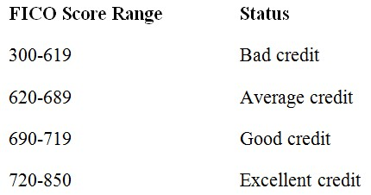
What five factors are typically looked at when a company is assigning you a credit score?

1. _______________________________
2. _______________________________
3. _______________________________
4. _______________________________
5. _______________________________
The Good and The Bad: Identify factors that will raise and lower your credit score.
RAISE MY SCORE | LOWER MY SCORE | WON’T CHANGE SCORE

Protect Your Credit: To prevent fraud, track your bills and overall credit regularly.
How often should you check your credit card statement? ____________________________________
How often should you check your credit report? ___________________________________________
What should you do if you identify a fraudulent charge on your statement? ____________________
What is the downside if you delay in disputing a fraudulent charge? ___________________________

